Module 3

Moving the Robot

# Introduction to Motor Blocks

## Motors

The motors are used to make your robot perform actions. There are 2 sizes of motors, the medium and the large.

### Medium

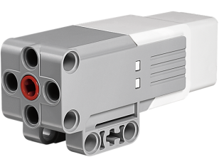

### Large

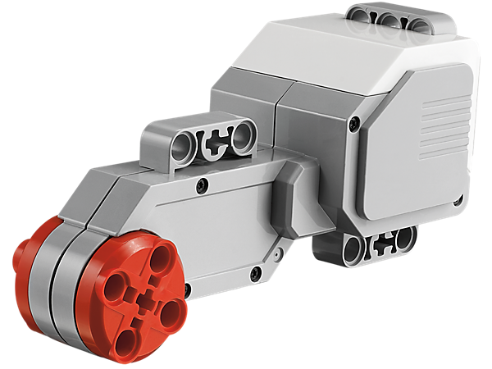

## Single Motor Blocks

The blocks used to control these motors are explained below.

### Medium

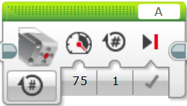

Mode

Power

Distance

Speed

Motor Port

### Large

This block is exactly the same except for the image of a large motor on it.

## Double Motor Blocks

### Move Steering

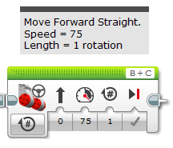

Left Motor Port

Right Motor Port

Direction of Movement

Power

Brake when finished

Number of Rotations

Mode

### Move Tank

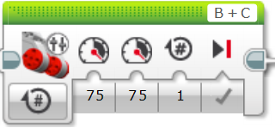

Left Motor Port

Right Motor Port

Left Motor Power

Right Motor Power

Brake when finished

Number of Rotations

Mode

# Activity 1 – Moving Straight

## Move Steering

Move forward 5 rotations in a straight line using the block below.

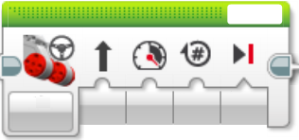

## Move Tank

Move forward 5 rotations in a straight line using the block below.

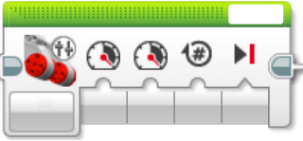

# Activity 2 – Turning

1. Point Turn
2. Move forward 2 rotations, turn left in one spot as shown below. Then move forward 1 rotation. Use the move tank block to turn.

*Hint – What happens if the powers on the left and right motors are different?*



1. Repeat part i using the move steering block.

*Hint – What happens if the direction is very high or low?*

1. Single Motor Turn
2. Place a straight line of tape on the floor. Move straight down the tape with one wheel on the tape, turn around after 2 rotations and return to the start. The wheel on the tape cannot leave the tape.
3. Make the turn shown below using the move steering block.



1. Repeat part e using the move tank block.

